2024 Bulletin Board Contest
Rules:
The Bulletin Board Contest is open to any K-4th grade class in Anderson County. Bulletin board projects are a class effort and should include work of all students in the class. School groups such as science clubs, environmental clubs, or other after school programs are welcome to compete. There is no restriction on the size of the bulletin board.

Create a unique bulletin board outside your classroom (or inside) that showcases the theme of the year “May the Forest Be with You, Always.” Be creative and inspiring!

Topic:
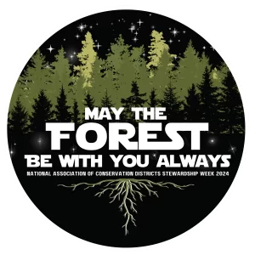
This theme underscores the critical interplay between soil and water conservation and the resilience of our forests. Forests play multifaceted roles in sustaining our planet, serving as sources of oxygen, carbon storage, and vibrant hubs of biodiversity. They function as steadfast protectors of soil and water resources, preventing erosion, purifying contaminants, and nurturing healthy watersheds. In today’s context, marked by environmental challenges, resilient forests are indispensable in fostering a sustainable world. The phrase “May the Forest Be with You, Always” signifies our commitment to responsible forest stewardship, emphasizing their enduring strength and adaptability.
Prizes:
One class/group will be selected, for an ice cream party, on a county-wide basis. Multi-grade groups (i.e. science clubs, etc.) will be judged at the highest grade level represented by the group. Winners will be contacted by ASWCD to set up a date for your ice cream party!

Deadline: March 22nd, 2024
All participating schools should contact the Anderson Soil & Water Conservation District office by March 11th to sign-up for a time to have their entries judged before the deadline. Please contact ASWCD if you have any questions or need further information.

